SENIOR SIX TERM 3 GEOGRAPHY LESSON NOTES 2026
TOPIC 1/1: Utilisation and Conservation of Natural Resources
Competency: The learner evaluates efforts aimed at conserving natural resources by examining their effectiveness as a basis for recommending alternative strategies to ensure wise and sustainable use of resources.

Resources and their Nature
A resource is anything from the natural environment or human-made systems that can be used to meet human needs, support survival, or drive development. Resources provide value because they are useful, accessible, and often limited.

Nature of a Resource
- Utility: A resource must serve a purpose (e.g., water for drinking, land for farming).
- Availability: It must be accessible for use, either naturally or through technology.
- Value: Its importance depends on human demand and the ability to harness it.
- Dynamic concept: What counts as a resource can change over time (e.g., wind was not considered valuable until wind turbines were developed).
Types of Resources
- Natural resources: Found in nature (forests, minerals, water, sunlight).
- Human resources: Skills, knowledge, and labor of people.
- Capital resources: Tools, machines, and infrastructure created to produce goods.

Main category of Natural Resources
- Renewable resources: Can regenerate naturally if used sustainably. Examples: forests, water, solar energy, wind, fish stocks.
- Non-renewable resources: Finite and exhaustible; once depleted, they cannot be replaced within human timescales. Examples: coal, oil, natural gas, minerals, metals.
- Biotic resources: Derived from living organisms. Examples: timber, crops, animals, fish.
- Abiotic resources: Originating from non-living elements of nature. Examples: water, air, soil, minerals, sunlight.
- Potential resources: Resources that exist but are not yet fully utilized. Example: wind energy in remote areas, untapped oil reserves.
- Actual resources: Resources currently exploited and in use. Example: cultivated farmland, operating oil fields.
A map of Uganda showing area with mineral potential
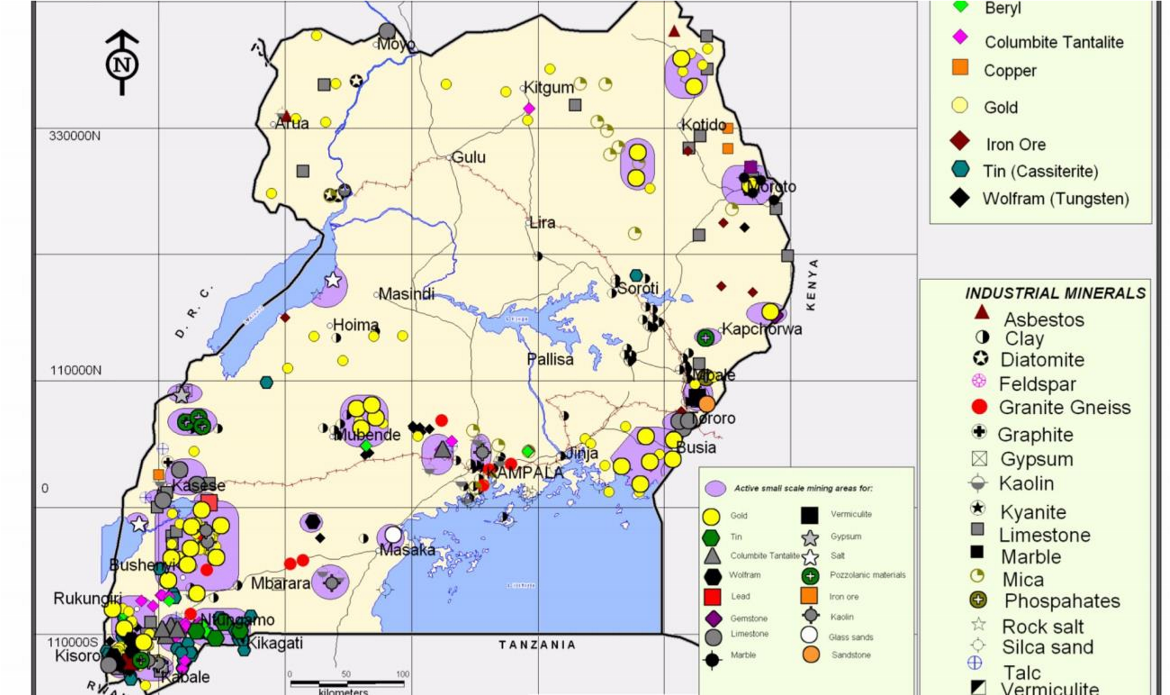

Summary Table
Category | Examples | Key Feature
Renewable | Forests, water, solar, wild animals | Can regenerate naturally
Non-renewable | Oil, coal, minerals | Finite, exhaustible
Biotic | Timber, fish, crops, wild aninals | Derived from living organisms
Abiotic | Water, air, soil, sunlight | Non-living sources
Potential | Untapped wind, oil reserves | Not yet fully utilized
Actual | Farmland, active mines | Currently exploited

Key Takeaway
Natural resources are the foundation of human survival and development. By distinguishing between renewable and non-renewable, biotic and abiotic, potential and actual, we can devise strategies for sustainable use that balance present needs with future generations.

Map of Uganda showing National Parks
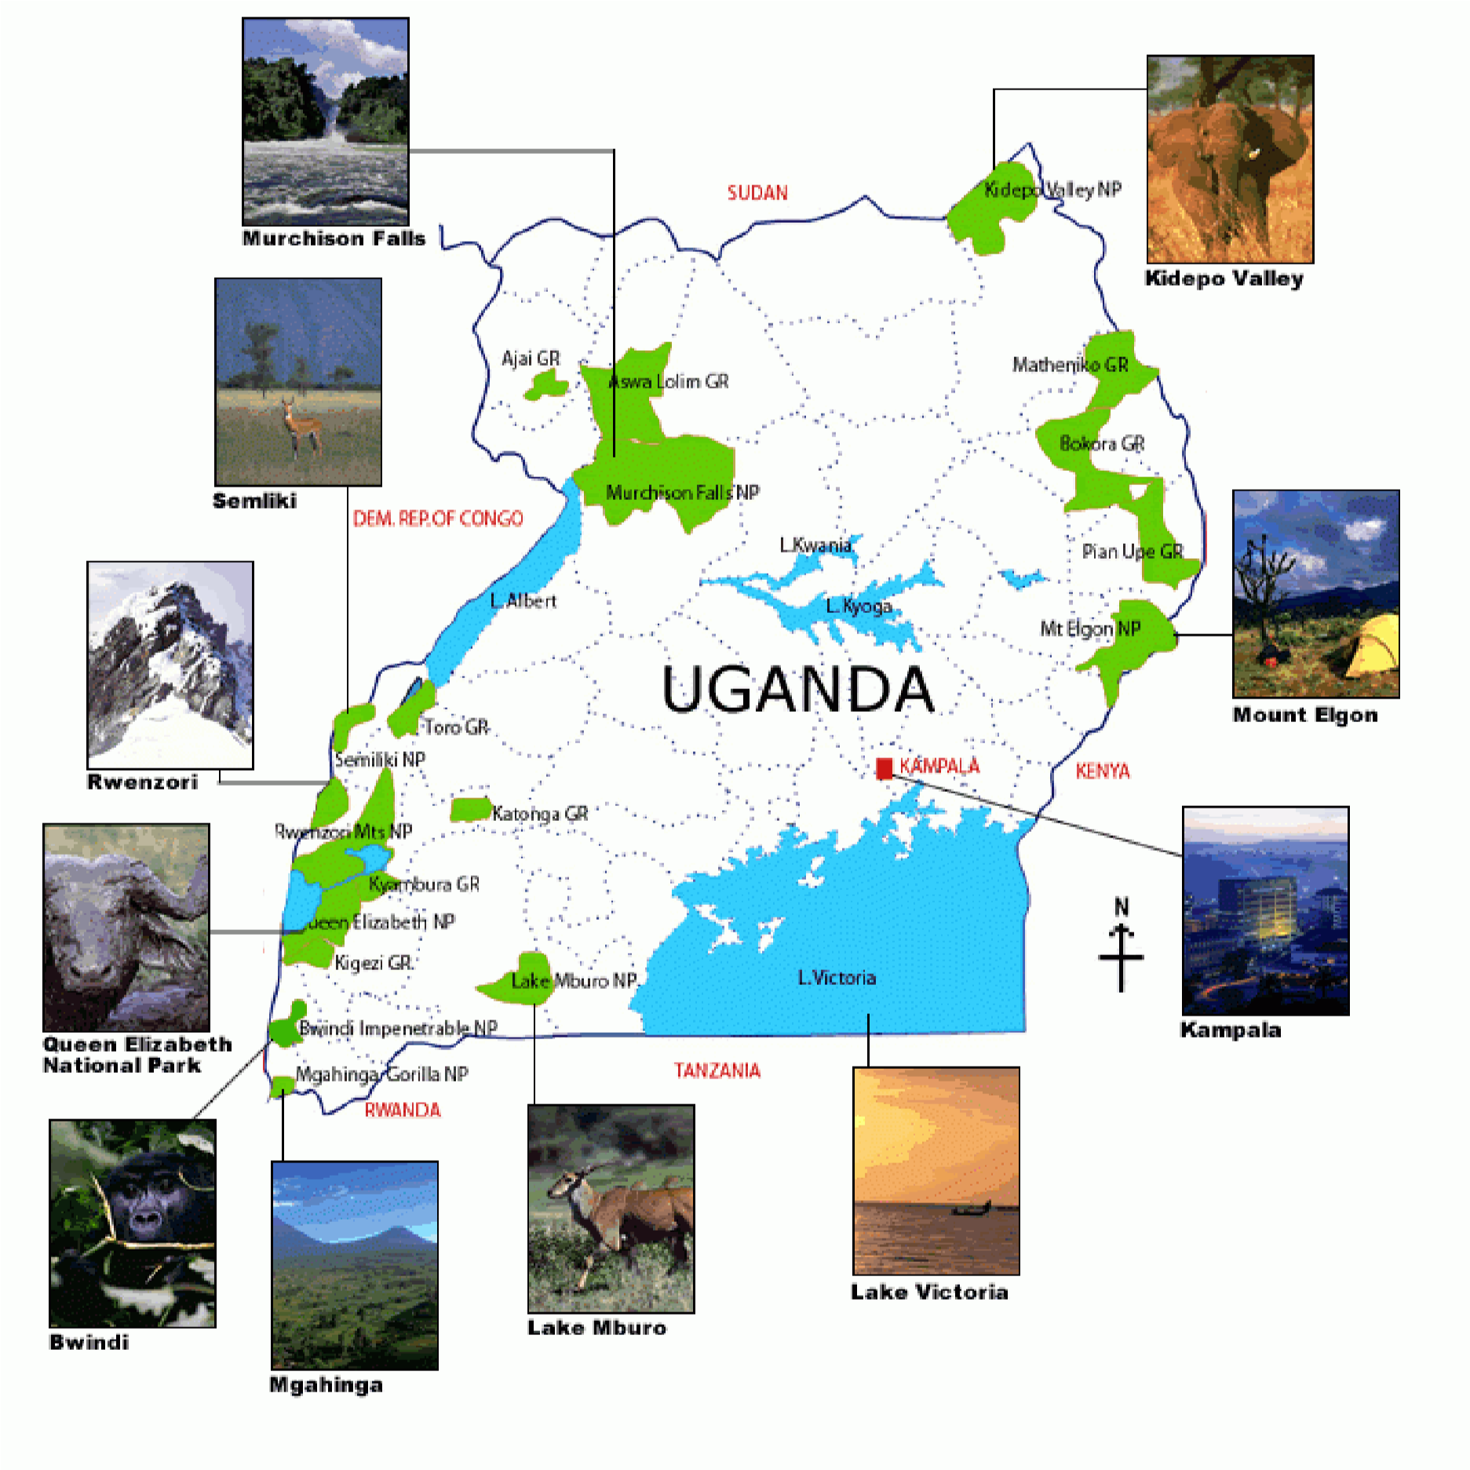

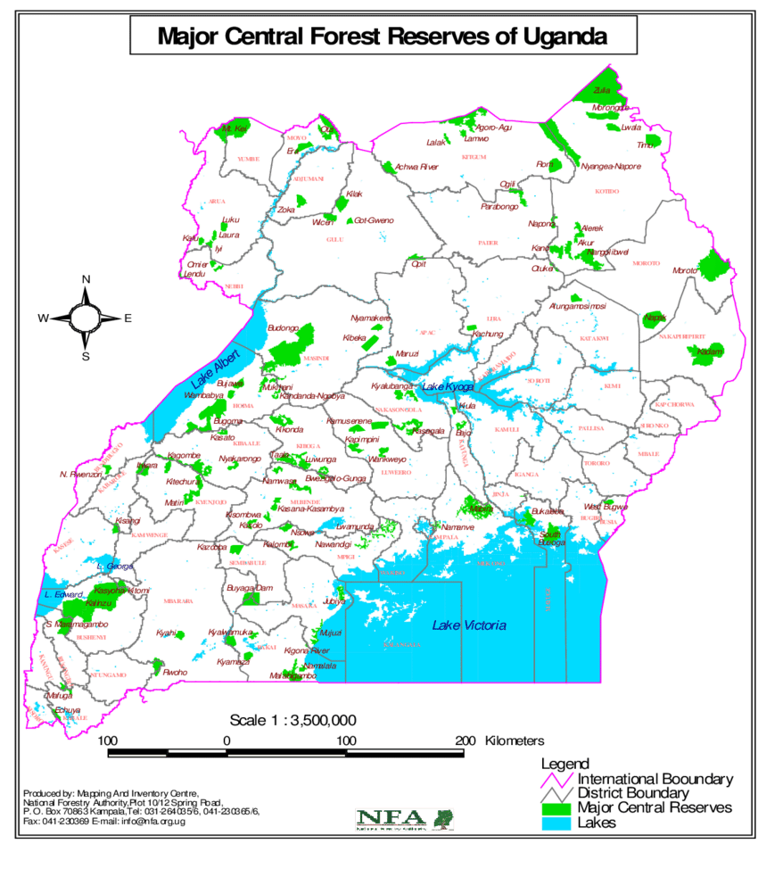

Challenges facing the exploitation of Natural resources of developing countries like Uganda
Exploiting natural resources in developing countries such as Uganda is often hindered by a mix of economic, environmental, political, and social challenges. These obstacles limit the ability to use resources sustainably and equitably.
- Limited technology and infrastructure o Outdated farming, mining, and energy systems reduce efficiency. o Poor transport and storage facilities lead to wastage (e.g., post-harvest losses in agriculture).
- Inadequate capital and investment o Lack of funding for modern equipment and sustainable practices.
  - Heavy reliance on foreign investors, often leading to exploitation.
- Environmental degradation o Deforestation, soil erosion, and water pollution from unsustainable practices.
  - Climate change intensifies droughts and floods, reducing productivity.
- Weak governance and corruption o Mismanagement of resource revenues (e.g., oil and minerals).
  - Illegal logging, poaching, and unregulated mining undermine sustainability.
- Population pressure o Rapid growth increases demand for land, water, and energy.
  - Overexploitation leads to depletion of forests, fisheries, and soils.
- Low value addition o Resources exported raw (timber, coffee, minerals) instead of processed.
  - Limits job creation and economic diversification.
- Land tenure conflicts o Disputes over ownership and access hinder resource management.
  - Customary vs. formal land rights create uncertainty for investors.
- External dependency o Dependence on global markets makes resource economies vulnerable to price fluctuations.
  - Example: Coffee and oil prices directly affect Uganda’s revenue.

Proposal to sustainable Utilization of Natural resources in developing countries like Uganda
Natural resources are the backbone of development in countries like Uganda, but unsustainable exploitation has led to deforestation, soil erosion, water scarcity, and biodiversity loss. This proposal outlines strategies to ensure resources are used wisely, equitably, and sustainably.

Guiding Principles
- Sustainability: Meet present needs without compromising future generations. • Equity: Ensure fair access for all communities, especially vulnerable groups.
- Resilience: Build systems that withstand climate change and economic shocks. • Value addition: Process resources locally to maximize economic benefits.

Strategic Areas of Action
- Forests and Biodiversity o Promote reforestation and afforestation programs.
  - Strengthen community forest management and eco-tourism.
  - Enforce laws against illegal logging and poaching.
- Water Resources o Invest in rainwater harvesting and irrigation systems.
  - Protect wetlands and river catchments from encroachment.
  - Promote clean water technologies and reduce pollution.
- Agriculture and Land o Encourage crop rotation, agroforestry, and organic farming. o Provide training and incentives for climate-smart agriculture.
  - Secure land tenure to reduce conflicts and promote sustainable use.
- Minerals and Energy o Regulate mining to minimize environmental damage. o Invest in renewable energy (solar, wind, hydropower).
  - Encourage local processing of minerals to create jobs.
- Human Capacity and Governance o Strengthen institutions for resource monitoring and enforcement. o Promote transparency to reduce corruption in resource management. o Educate communities on sustainable practices and conservation.

Implementation Framework
Sector | Proposed Action | Expected Outcome
Forests | Reforestation, community management | Reduced deforestation, improved biodiversity
Water | Irrigation, wetland protection | Increased water security, reduced drought impacts
Agriculture | Climate-smart farming | Higher yields, soil conservation
Minerals/Energy | Renewable energy, regulated mining | Sustainable growth, reduced pollution
Governance | Transparency, education | Better accountability, empowered communities
Key Takeaway
Sustainable utilization of natural resources in Uganda requires a multi-sector approach: protecting ecosystems, modernizing agriculture, investing in renewable energy, and strengthening governance. By balancing economic growth with environmental stewardship, Uganda can transform its resources into long-term prosperity.

Wetlands
A wetland is defined as a low-lying area of land that is saturated with water, either permanently or seasonally, creating conditions that support distinct soils, plants, and wildlife. Wetlands act as transitional zones between terrestrial (land) and aquatic (water) ecosystems.

Characteristics of Wetlands
- Waterlogged soils: Known as hydric soils, they remain saturated and oxygen-poor.
- Specialized vegetation: Support plants adapted to wet conditions (hydrophytes), such as reeds, mangroves, and cattails.
- Dynamic hydrology: Water levels fluctuate due to rainfall, river flow, or tides.
- Biodiversity hotspots: Provide habitats for fish, birds, amphibians, and insects.

Types of Wetlands
- Marshes: Dominated by grasses and herbaceous plants.
- Swamps: Forested wetlands with trees and shrubs.
- Bogs: Peat-rich wetlands with acidic, nutrient-poor conditions.
- Fens: Peat-forming wetlands fed by groundwater, more nutrient-rich than bogs.
- Mangroves & estuarine wetlands: Found along tropical coasts, influenced by tides.
Importance of Wetlands
- Flood control: Absorb excess water during heavy rains.
- Water purification: Filter pollutants and sediments.
- Carbon storage: Peatlands and mangroves store large amounts of carbon.
- Livelihoods: Provide fish, reeds, and tourism opportunities.
- Biodiversity: Support diverse ecosystems crucial for ecological balance.

Policies in Uganda to protect wetlands
Uganda protects its wetlands through a mix of national policies, environmental regulations, and international commitments. These frameworks aim to conserve wetlands, regulate their use, and restore degraded areas.

Key Policies and Regulations
- National Policy for the Conservation and Management of Wetland Resources (1995) o First comprehensive policy dedicated to wetlands in Uganda. o Promotes sustainable use, environmentally sound management, and conservation.
  - Includes strategies for drainage control, recovery of degraded wetlands, environmental impact assessments, and public awareness.
- National Environment (Wetlands, River Banks, and Lake Shores Management) Regulations
(2000) o Provides legal guidelines for managing wetlands, riverbanks, and lake shores.
  - Restricts harmful activities such as unregulated farming, construction, and industrial waste disposal. o Requires permits for activities that may affect wetlands and mandates rehabilitation of degraded areas.
- National Environment (Declaration of Wetlands) Notice, 2023 o Official gazetting of all wetlands in Uganda.
  - Strengthens legal protection by recognizing wetlands as critical ecosystems for climate resilience and livelihoods.
  - Aligns with Uganda’s obligations under the Ramsar Convention on Wetlands.
- Institutional Framework o The National Environment Management Authority (NEMA) oversees enforcement.
  - Local governments and community-based organizations are involved in monitoring and conservation.
  - Partnerships with UNDP and NGOs support restoration projects and awareness campaigns.

Summary Table
Policy/Regulation | Year | Focus | Key Measures
National Wetland Policy | 1995 | Conservation & sustainable use | Drainage control, recovery, awareness, EIA
Wetlands Regulations | 2000 | Legal management | Permits, restrictions, rehabilitation
Declaration of Wetlands  Notice | 2023 | Legal gazetting | Official protection, climate resilience
Institutional Framework | Ongoing | Enforcement & monitoring | NEMA, local gov’t, NGOs

Challenges in Implementation
- Encroachment: Agriculture, urban expansion, and industrial development continue to degrade wetlands.
- Weak enforcement: Limited resources and corruption hinder effective monitoring.
- Population pressure: Rising demand for land and water increases exploitation.
- Climate change: Alters hydrology, threatening wetland ecosystems.
Key Takeaway
Uganda’s wetland protection policies combine legal frameworks, conservation strategies, and international commitments. While significant progress has been made—such as gazetting all wetlands in 2023—implementation challenges remain, requiring stronger enforcement, community involvement, and climate adaptation measures.
Measures to Promote Sustainable Use of Wetlands in Uganda
- Strengthen legal protection: Enforce the National Environment (Wetlands, River Banks, and Lake Shores Management) Regulations. Gazette wetlands to prevent illegal encroachment and industrial exploitation.
- Community-based management: Empower local communities to manage wetlands through co-management agreements. Promote eco-tourism and sustainable harvesting of reeds, papyrus, and fish.
- Restoration and conservation projects: Rehabilitate degraded wetlands through replanting native vegetation. Control pollution by regulating waste disposal from industries and urban centers.
- Climate-smart agriculture: Encourage farming practices that reduce wetland encroachment, such as upland farming and agroforestry. Provide alternative livelihoods to reduce dependence on wetland cultivation.
- Awareness and education: Conduct public campaigns on the importance of wetlands for flood control, water purification, and biodiversity. Integrate wetland conservation into school curricula.
- Research and monitoring: Establish wetland monitoring systems to track changes in size, biodiversity, and water quality. Support universities and NGOs in conducting studies on wetland ecosystem services.
- Promote alternative energy: Reduce reliance on wetland biomass (like papyrus and firewood) by expanding access to solar and biogas.
Environmental degradation
Environmental degradation refers to the deterioration of the natural environment through the depletion of resources, destruction of ecosystems, and pollution. It occurs when human activities or natural processes reduce the quality and capacity of the environment to sustain life.

Causes of Environmental Degradation
- Deforestation: Clearing forests for agriculture, settlement, and logging.
- Pollution: Air, water, and soil contamination from industries, vehicles, and waste.
- Overpopulation: Increased demand for land, water, and energy.
- Unsustainable agriculture: Overgrazing, monocropping, and excessive use of fertilizers and pesticides.
- Industrialization and mining: Extraction of minerals and fossil fuels damages land and ecosystems.
- Climate change: Rising temperatures, floods, and droughts intensify environmental stress.

Effects of Environmental Degradation
- Loss of biodiversity: Extinction of species and destruction of habitats.
- Soil erosion and desertification: Reduced agricultural productivity.
- Water scarcity and pollution: Unsafe drinking water and reduced freshwater availability.
- Health impacts: Respiratory diseases, waterborne illnesses, and malnutrition.
- Economic decline: Reduced tourism, fisheries, and agricultural output. (vi) Climate vulnerability: Increased floods, droughts, and storms.

Examples in Uganda
- Wetland encroachment: Conversion of wetlands into farmland and settlements.
- Deforestation: Logging and charcoal burning in forests like Mabira.
- Soil erosion: Overcultivation in hilly areas such as Kabale.
- Pollution: Industrial waste in Lake Victoria and urban centers.

Measures to Address Environmental Degradation
- Afforestation and reforestation programs.
- Wetland protection policies and restoration projects.
- Promotion of renewable energy (solar, biogas) to reduce deforestation.
- Waste management systems to control pollution.
- Community awareness and education on conservation.
- Stronger enforcement of environmental laws by agencies like NEMA.

Key Takeaway
Environmental degradation is a global challenge but particularly critical in developing countries like Uganda, where livelihoods depend heavily on natural resources. Tackling it requires sustainable resource management, strong policies, and community participation to protect ecosystems and ensure long-term development.

